**Assignment 2**

COSC2007: Data Structure II

Jeel Tikiwala

239659420

**Exercise No:**

1 - Construct a binary search tree to keep the records of the student’s names. You can insert the name of students that should follow the rules of binary search tree until press character ‘N’.

**Algorithm/ Pseudocode:**

// Define a class for the nodes of the BST

// Constructor to initialize the node with a name

// Define a class for the binary search tree

// A method to insert a new node with a given name into the tree

// If tree is empty, make the new node the root

// Otherwise, start from the root and traverse the tree

// Compare the name to the name of the active node.

// If the name is smaller than the current node's name, go to the left subtree

// If the name is larger than the current node's name, go to the right subtree

**Code:**

INSERT METHOD:

//insert method

**public** **static** Node insert(Node root, String key) {

**if**(root == **null**) {

root = **new** Node(key);

**return** root;

}

//if key is

**if**(key.compareTo(root.data) < 0) {

root.left = *insert*(root.left, key);

}

**else** {

root.right = *insert*(root.right, key);

}

**return** root;

}

MAIN METHOD:

// Q1: Construct a binary search tree

String studentNames[] = {"Jeel", "Rishit", "Bhakti", "Shubh", "Ashwin", "Shaan", "Diya"};

Node root = **null**;

//Multiple insert through for loop

**for**(**int** i=0; i<studentNames.length; i++) {

root = *insert*(root, studentNames[i]);

}

2 - Perform the search operation to find the particular student.

**Algorithm/ Pseudocode:**

// A method to search for a node with a given name in the tree

// Navigate the tree starting at the root.

// Compare the name to the name of the active node.

// If the name is smaller than the current node's name, go to the left subtree

// If the name is larger than the current node's name, go to the right subtree

// If the name is equal to the current node's name, return true

**Code:**

SEARCH METHOD:

//search method

**public** **static** **boolean** search(Node root, String studentNames) {

**if** (root == **null**) {

**return** **false**;

}

**int** comparison = studentNames.compareTo(root.data);

**if** (comparison < 0) {

// Search in the left subtree

**return** *search*(root.left, studentNames);

} **else** **if** (comparison > 0) {

// Search in the right subtree

**return** *search*(root.right, studentNames);

} **else** {

// If root is equal to studentNames

**return** **true**;

}

}

MAIN METHOD:

//Q2: Perform the search operation

String searchName = "Jeel";

**if**(*search*(root, searchName )) {

System.***out***.println("The name " + searchName + " is found in the BST.");

}

**else** {

System.***out***.println("Not Found in the BST.");

}

OUTPUT:

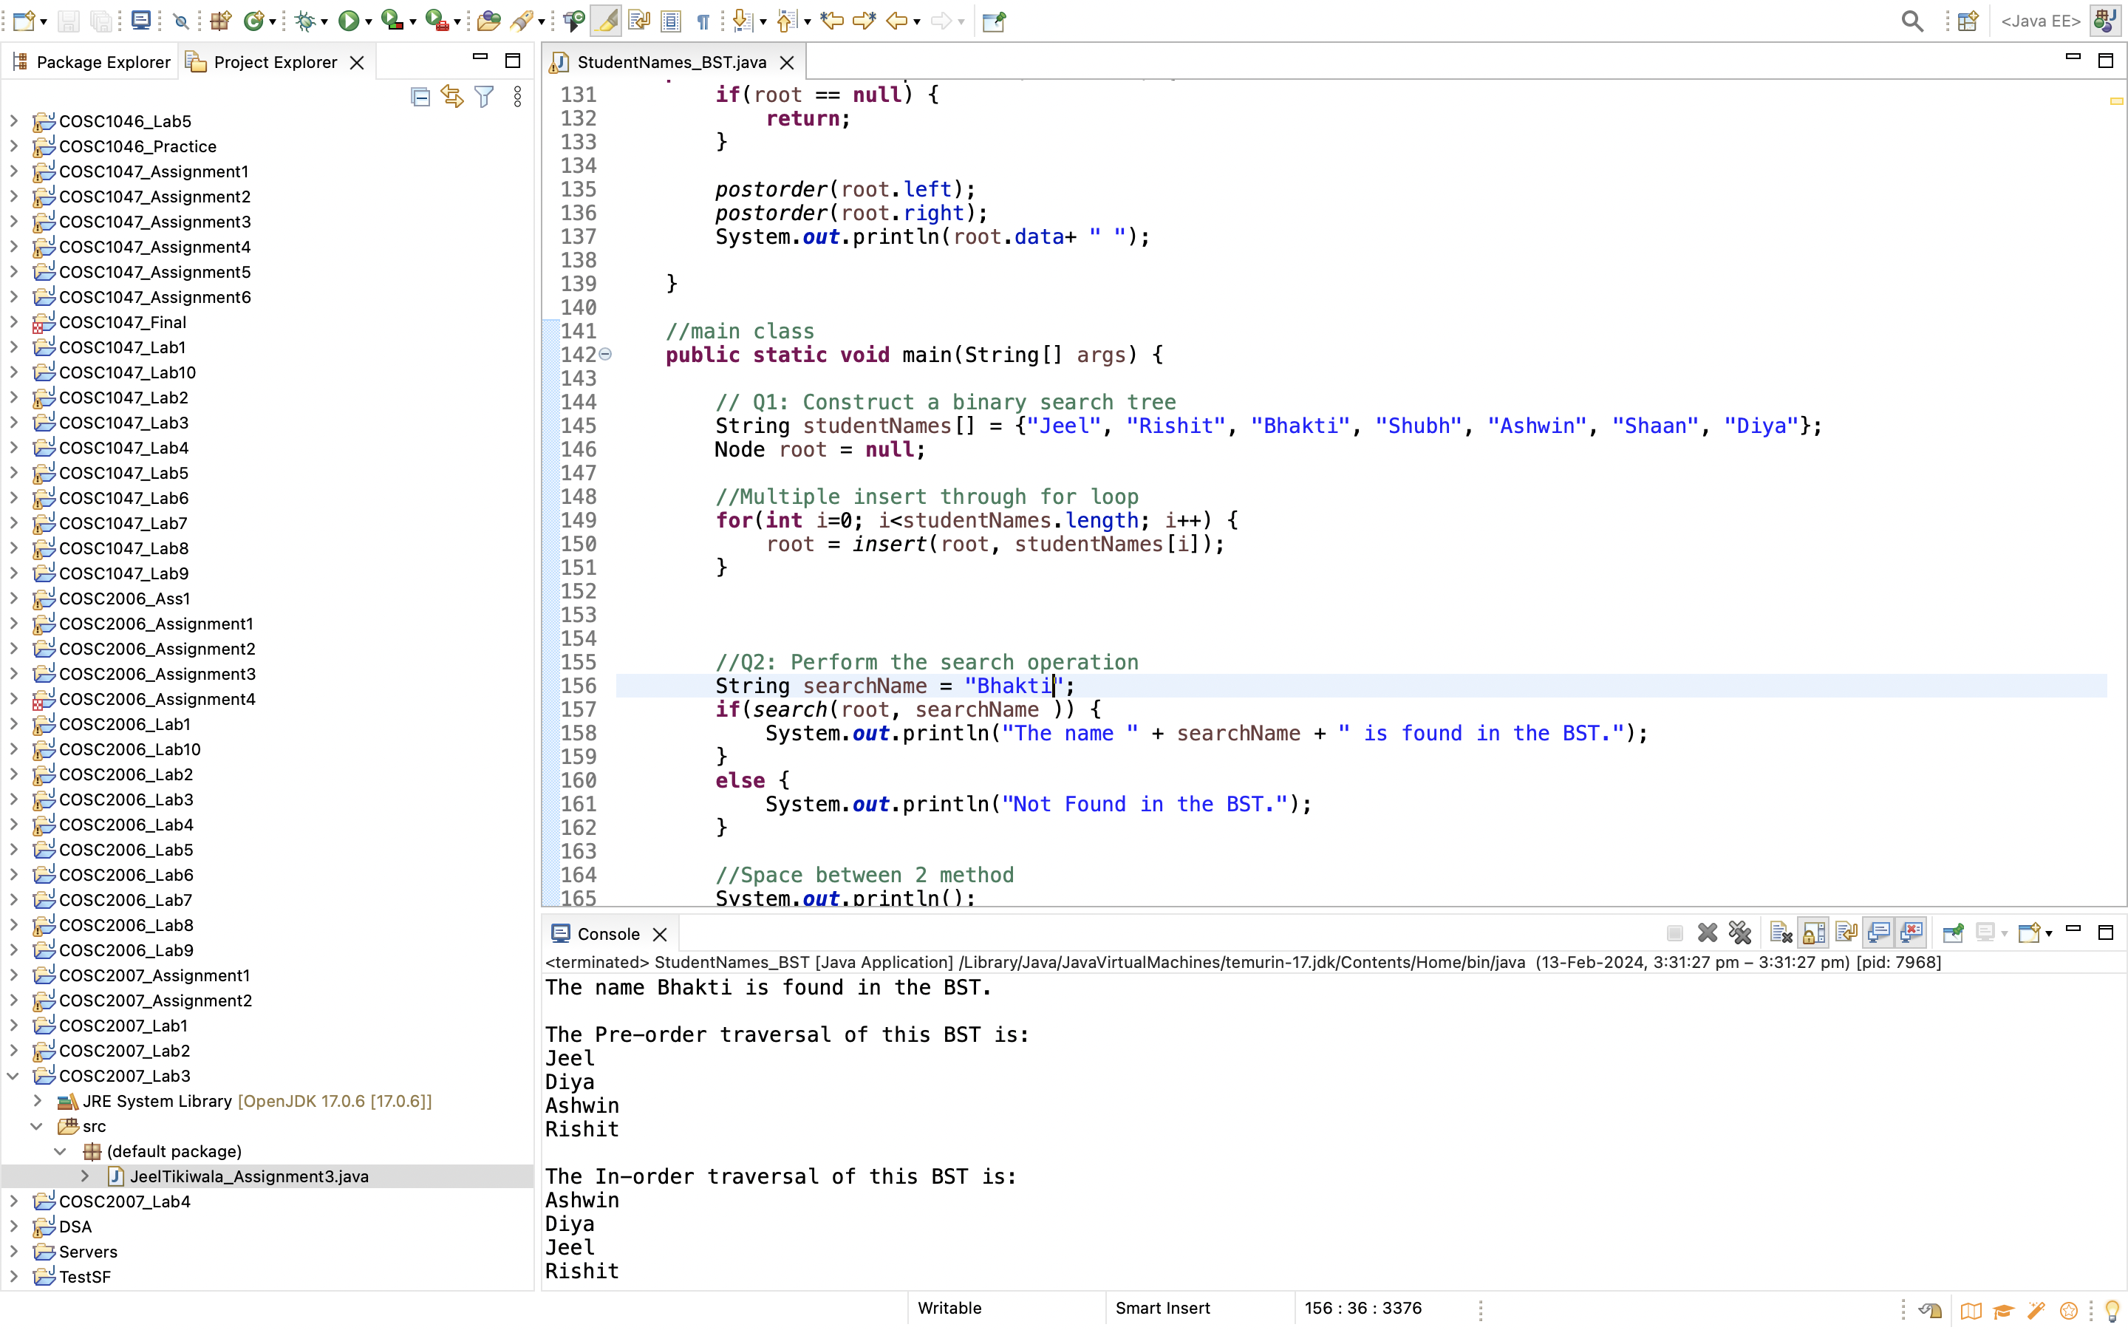

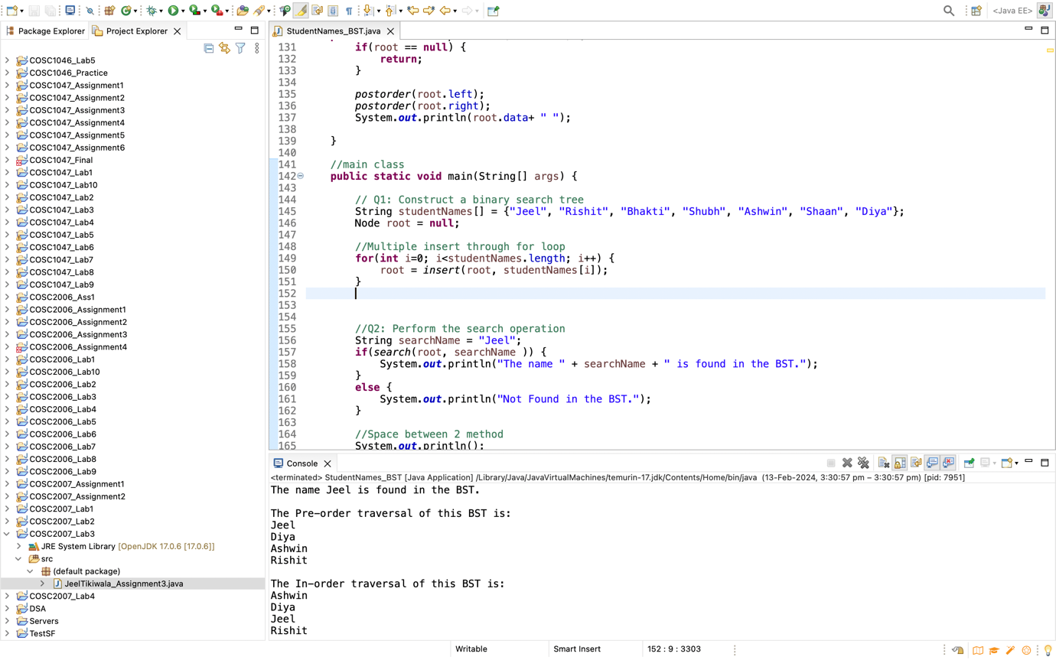

The student “Harshil” is not in the BST” so it returned not found.

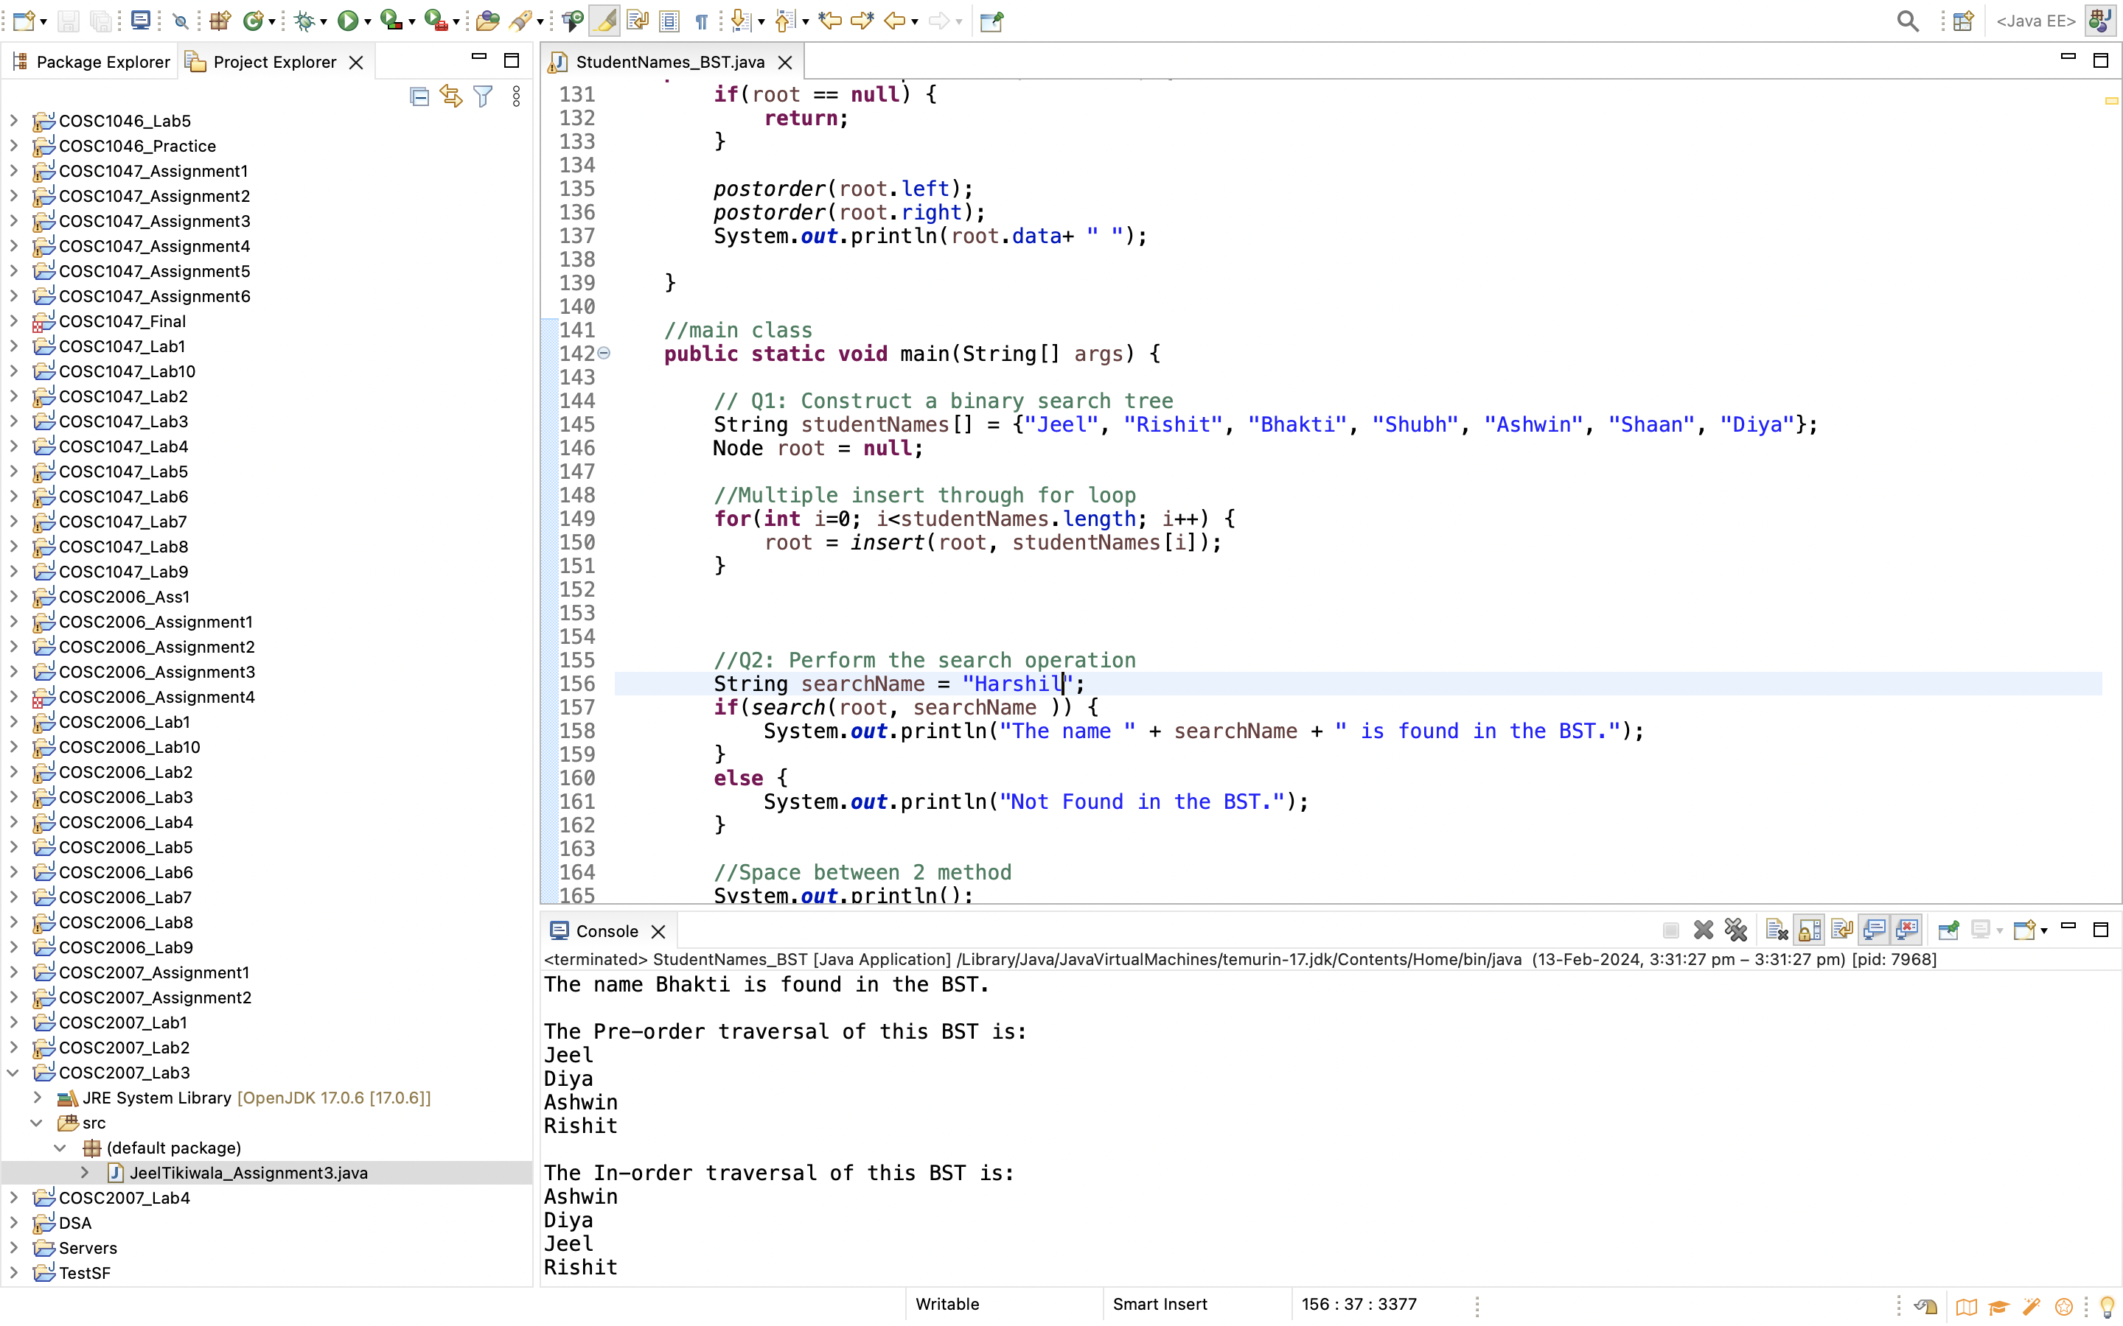

3- Delete any one leaf node student

**Algorithm/ Pseudocode**

// A method to delete a node with a given name from the tree

// Navigate the tree starting at the root.

// If the name is smaller than the current node's name, go to the left subtree

// If the name is larger than the current node's name, go to the right subtree

// Case 1: delete the node that has no children

// If left and right nodes are null, it’s a leaf

**Code**

DELETE METHOD:

//delete a node

**public** **static** Node delete(Node root, String studentNames) {

**int** comparison = studentNames.compareTo(root.data);

**if**(comparison < 0) {

root.left = *delete*(root.left,studentNames);

} **else** **if** (comparison > 0) {

// Search in the right subtree

root.right = *delete*(root.right, studentNames);

} **else** {

// we searched and reached at the node

//Case 1: 1st NO child - leaf node :: delete node and replace with null

**if**(root.left == **null** && root.right == **null**) {

**return** **null**;

}

//Case 2: 2nd One child :: delete node and replace with child node

**if**(root.left == **null**) {

**return** root.right;

}

**else** **if**(root.right == **null**) {

**return** root.left;

}

//Case 3: 3rd Two child:: replace value with inorder succesor, delete the node for inorder succesor

Node IS = *inorderSuccesssor*(root.right);

root.data = IS.data;

root.right = *delete*(root.right, IS.data);

}

**return** root;

}

//inorder succesor fucntion

**public** **static** Node inorderSuccesssor(Node root) {

**while**(root.left != **null**) {

root = root.left;

}

**return** root;

}

MAIN METHOD:

//Q3: Delete one leaf node

root = *delete*(root,"Shubh");

OUTPUT:

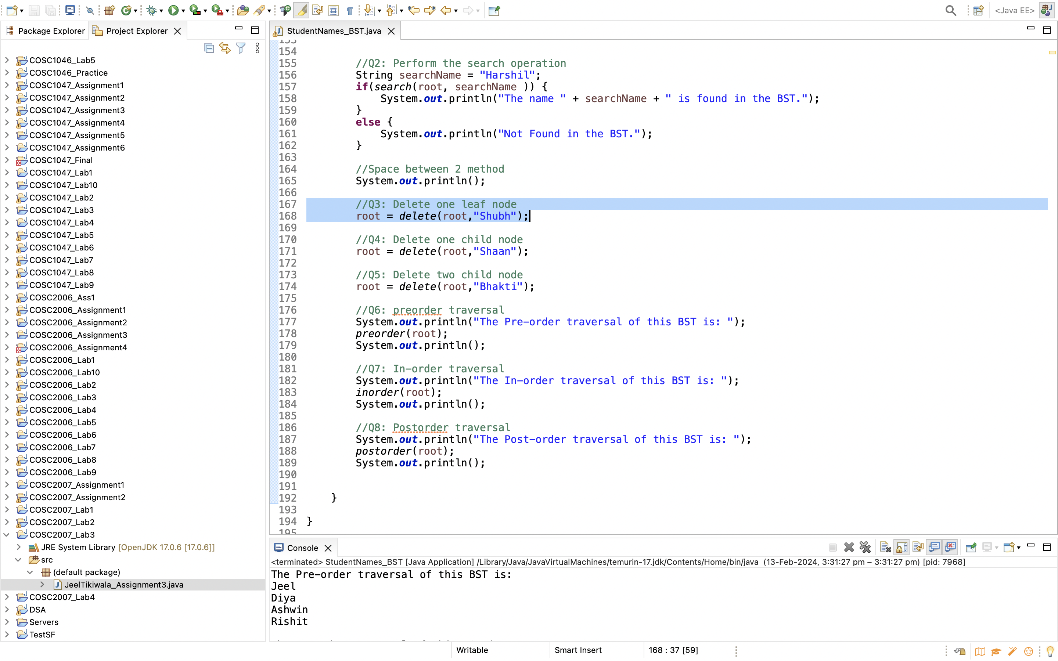

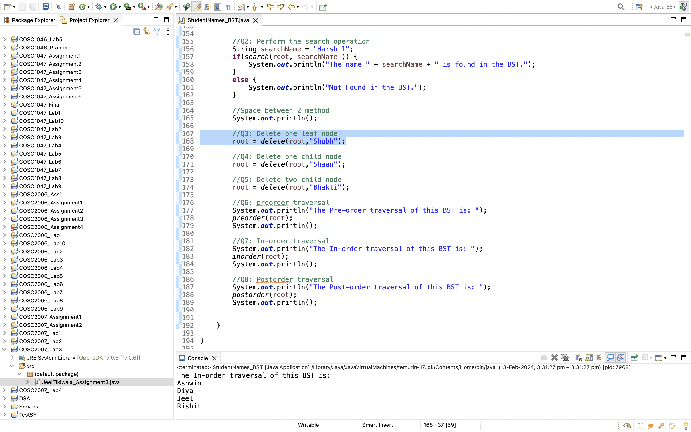

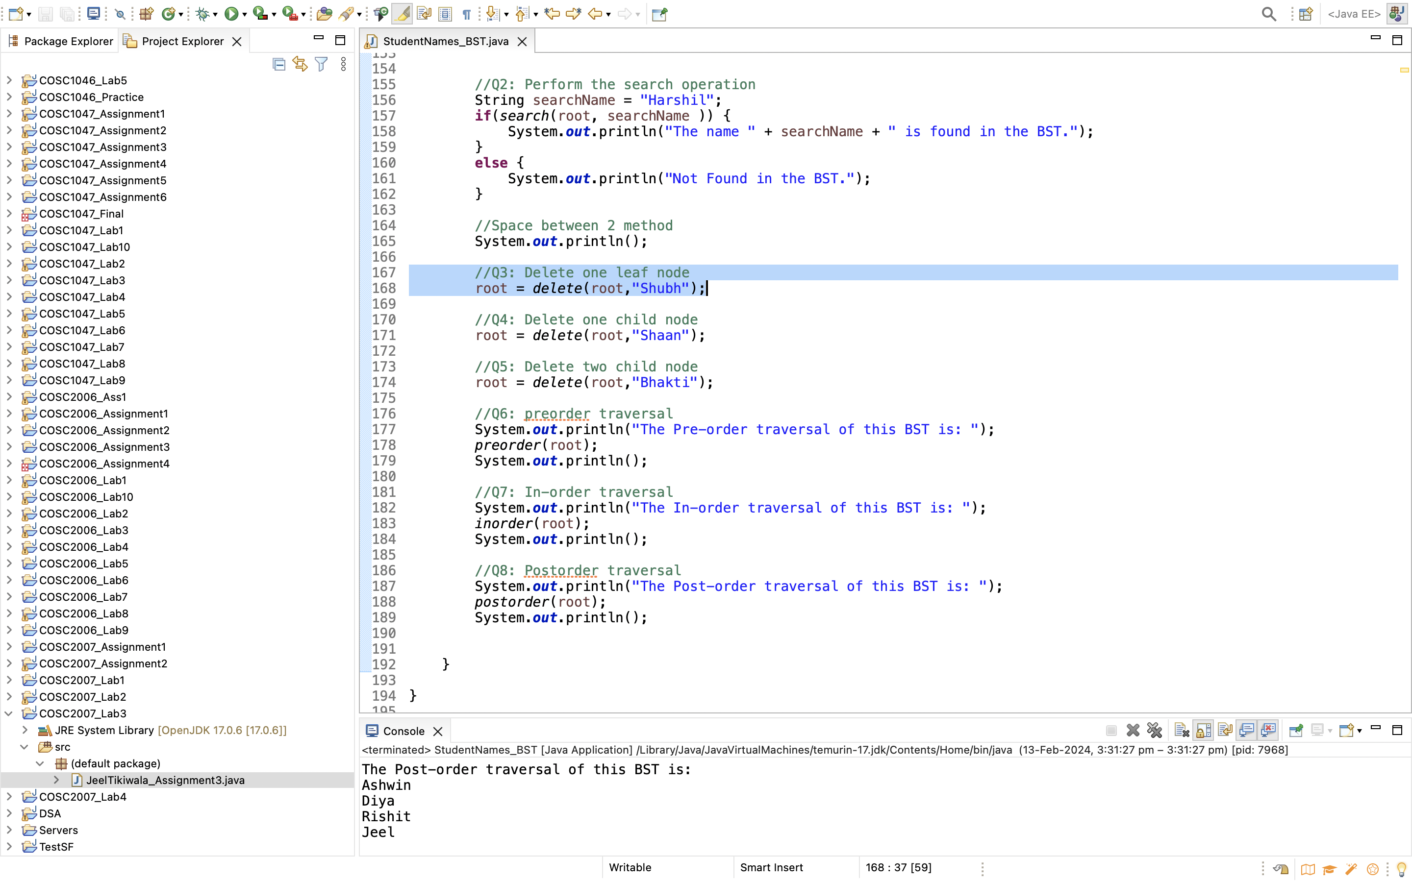

Conclusion:

4- Delete any one student with one child node

**Algorithm/ Pseudocode**

// A method to delete a node with a given name from the tree

// Navigate the tree starting at the root.

// If the name is smaller than the current node's name, go to the left subtree

// If the name is larger than the current node's name, go to the right subtree

// If left is null and right is null, delete the node and replace with child node

**Code**

DELETE METHOD:

//delete a node

**public** **static** Node delete(Node root, String studentNames) {

**int** comparison = studentNames.compareTo(root.data);

**if**(comparison < 0) {

root.left = *delete*(root.left,studentNames);

} **else** **if** (comparison > 0) {

// Search in the right subtree

root.right = *delete*(root.right, studentNames);

} **else** {

// we searched and reached at the node

//Case 1: 1st NO child - leaf node :: delete node and replace with null

**if**(root.left == **null** && root.right == **null**) {

**return** **null**;

}

//Case 2: 2nd One child :: delete node and replace with child node

**if**(root.left == **null**) {

**return** root.right;

}

**else** **if**(root.right == **null**) {

**return** root.left;

}

//Case 3: 3rd Two child:: replace value with inorder succesor, delete the node for inorder succesor

Node IS = *inorderSuccesssor*(root.right);

root.data = IS.data;

root.right = *delete*(root.right, IS.data);

}

**return** root;

}

//inorder succesor fucntion

**public** **static** Node inorderSuccesssor(Node root) {

**while**(root.left != **null**) {

root = root.left;

}

**return** root;

}

MAIN METHOD:

//Q4: Delete one child node

root = *delete*(root,"Shaan");

1. - Delete any one student with two child nodes.

**Algorithm/ Pseudocode**

// A method to delete a node with a given name from the tree

// Navigate the tree starting at the root.

// If the name is smaller than the current node's name, go to the left subtree

// If the name is larger than the current node's name, go to the right subtree

// replace value with inorder successor, delete the node for inorder successor

**Code**

**Delete method**

//delete a node

**public** **static** Node delete(Node root, String studentNames) {

**int** comparison = studentNames.compareTo(root.data);

**if**(comparison < 0) {

root.left = *delete*(root.left,studentNames);

} **else** **if** (comparison > 0) {

// Search in the right subtree

root.right = *delete*(root.right, studentNames);

} **else** {

// we searched and reached at the node

//Case 1: 1st NO child - leaf node :: delete node and replace with null

**if**(root.left == **null** && root.right == **null**) {

**return** **null**;

}

//Case 2: 2nd One child :: delete node and replace with child node

**if**(root.left == **null**) {

**return** root.right;

}

**else** **if**(root.right == **null**) {

**return** root.left;

}

//Case 3: 3rd Two child:: replace value with inorder succesor, delete the node for inorder succesor

Node IS = *inorderSuccesssor*(root.right);

root.data = IS.data;

root.right = *delete*(root.right, IS.data);

}

**return** root;

}

//inorder succesor fucntion

**public** **static** Node inorderSuccesssor(Node root) {

**while**(root.left != **null**) {

root = root.left;

}

**return** root;

}

MAIN METHOD

//main class

**public** **static** **void** main(String[] args) {

// Q1: Construct a binary search tree

String studentNames[] = {"Jeel", "Rishit", "Bhakti", "Shubh", "Ashwin", "Shaan", "Diya"};

Node root = **null**;

//Multiple insert through for loop

**for**(**int** i=0; i<studentNames.length; i++) {

root = *insert*(root, studentNames[i]);

}

//Q2: Perform the search operation

String searchName = "Harshil";

**if**(*search*(root, searchName )) {

System.***out***.println("The name " + searchName + " is found in the BST.");

}

**else** {

System.***out***.println("Not Found in the BST.");

}

//Space between 2 method

System.***out***.println();

//Q3: Delete one leaf node

root = *delete*(root,"Shubh");

//Q4: Delete one child node

root = *delete*(root,"Shaan");

//Q5: Delete two child node

root = *delete*(root,"Bhakti");

//Q6: preorder traversal

System.***out***.println("The Pre-order traversal of this BST is: ");

*preorder*(root);

System.***out***.println();

//Q7: In-order traversal

System.***out***.println("The In-order traversal of this BST is: ");

*inorder*(root);

System.***out***.println();

//Q8: Postorder traversal

System.***out***.println("The Post-order traversal of this BST is: ");

*postorder*(root);

System.***out***.println();

}

}

OUTPUT:

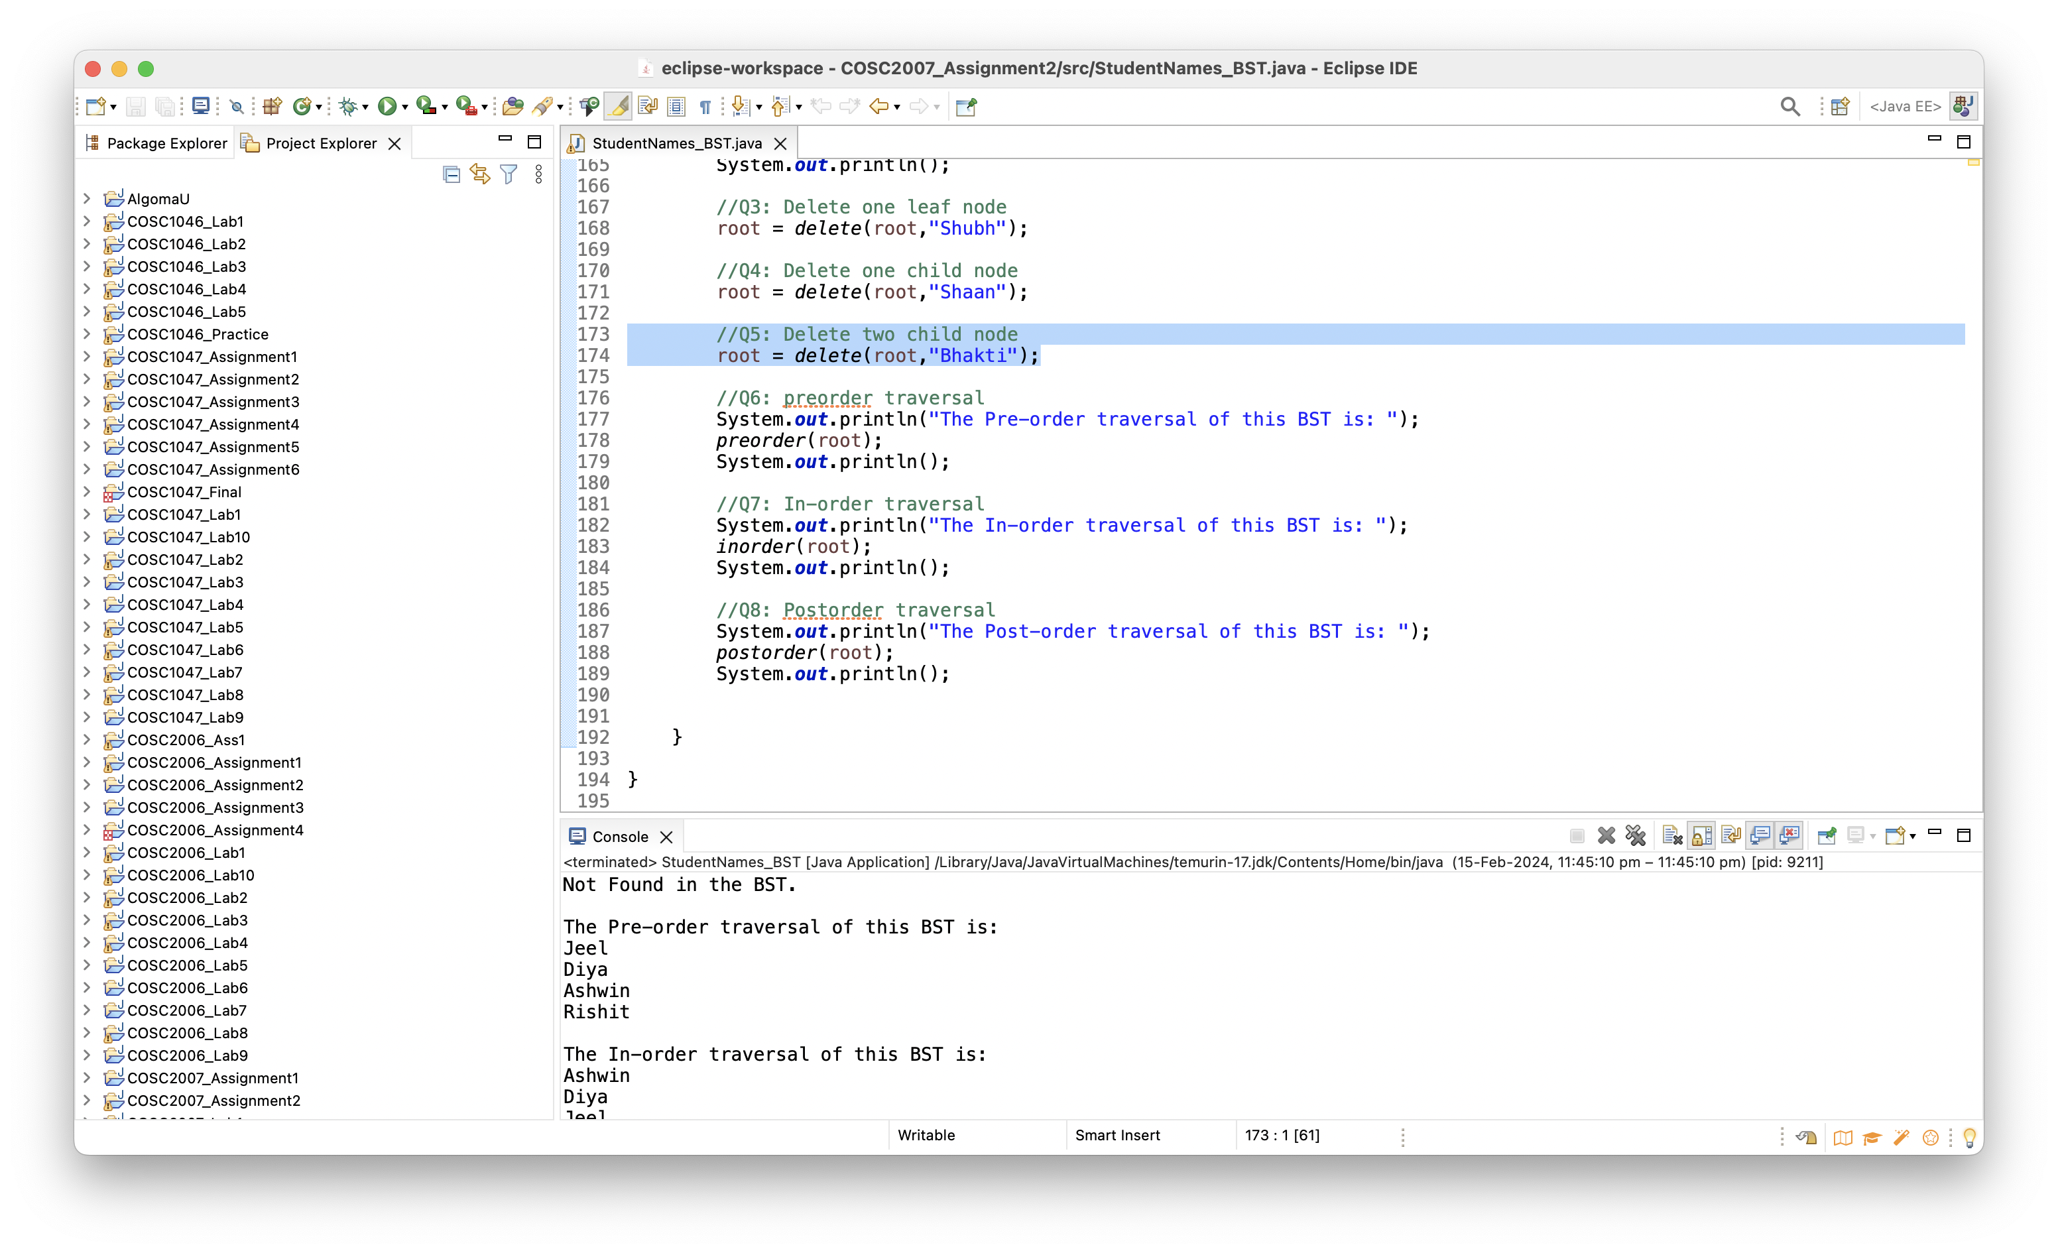

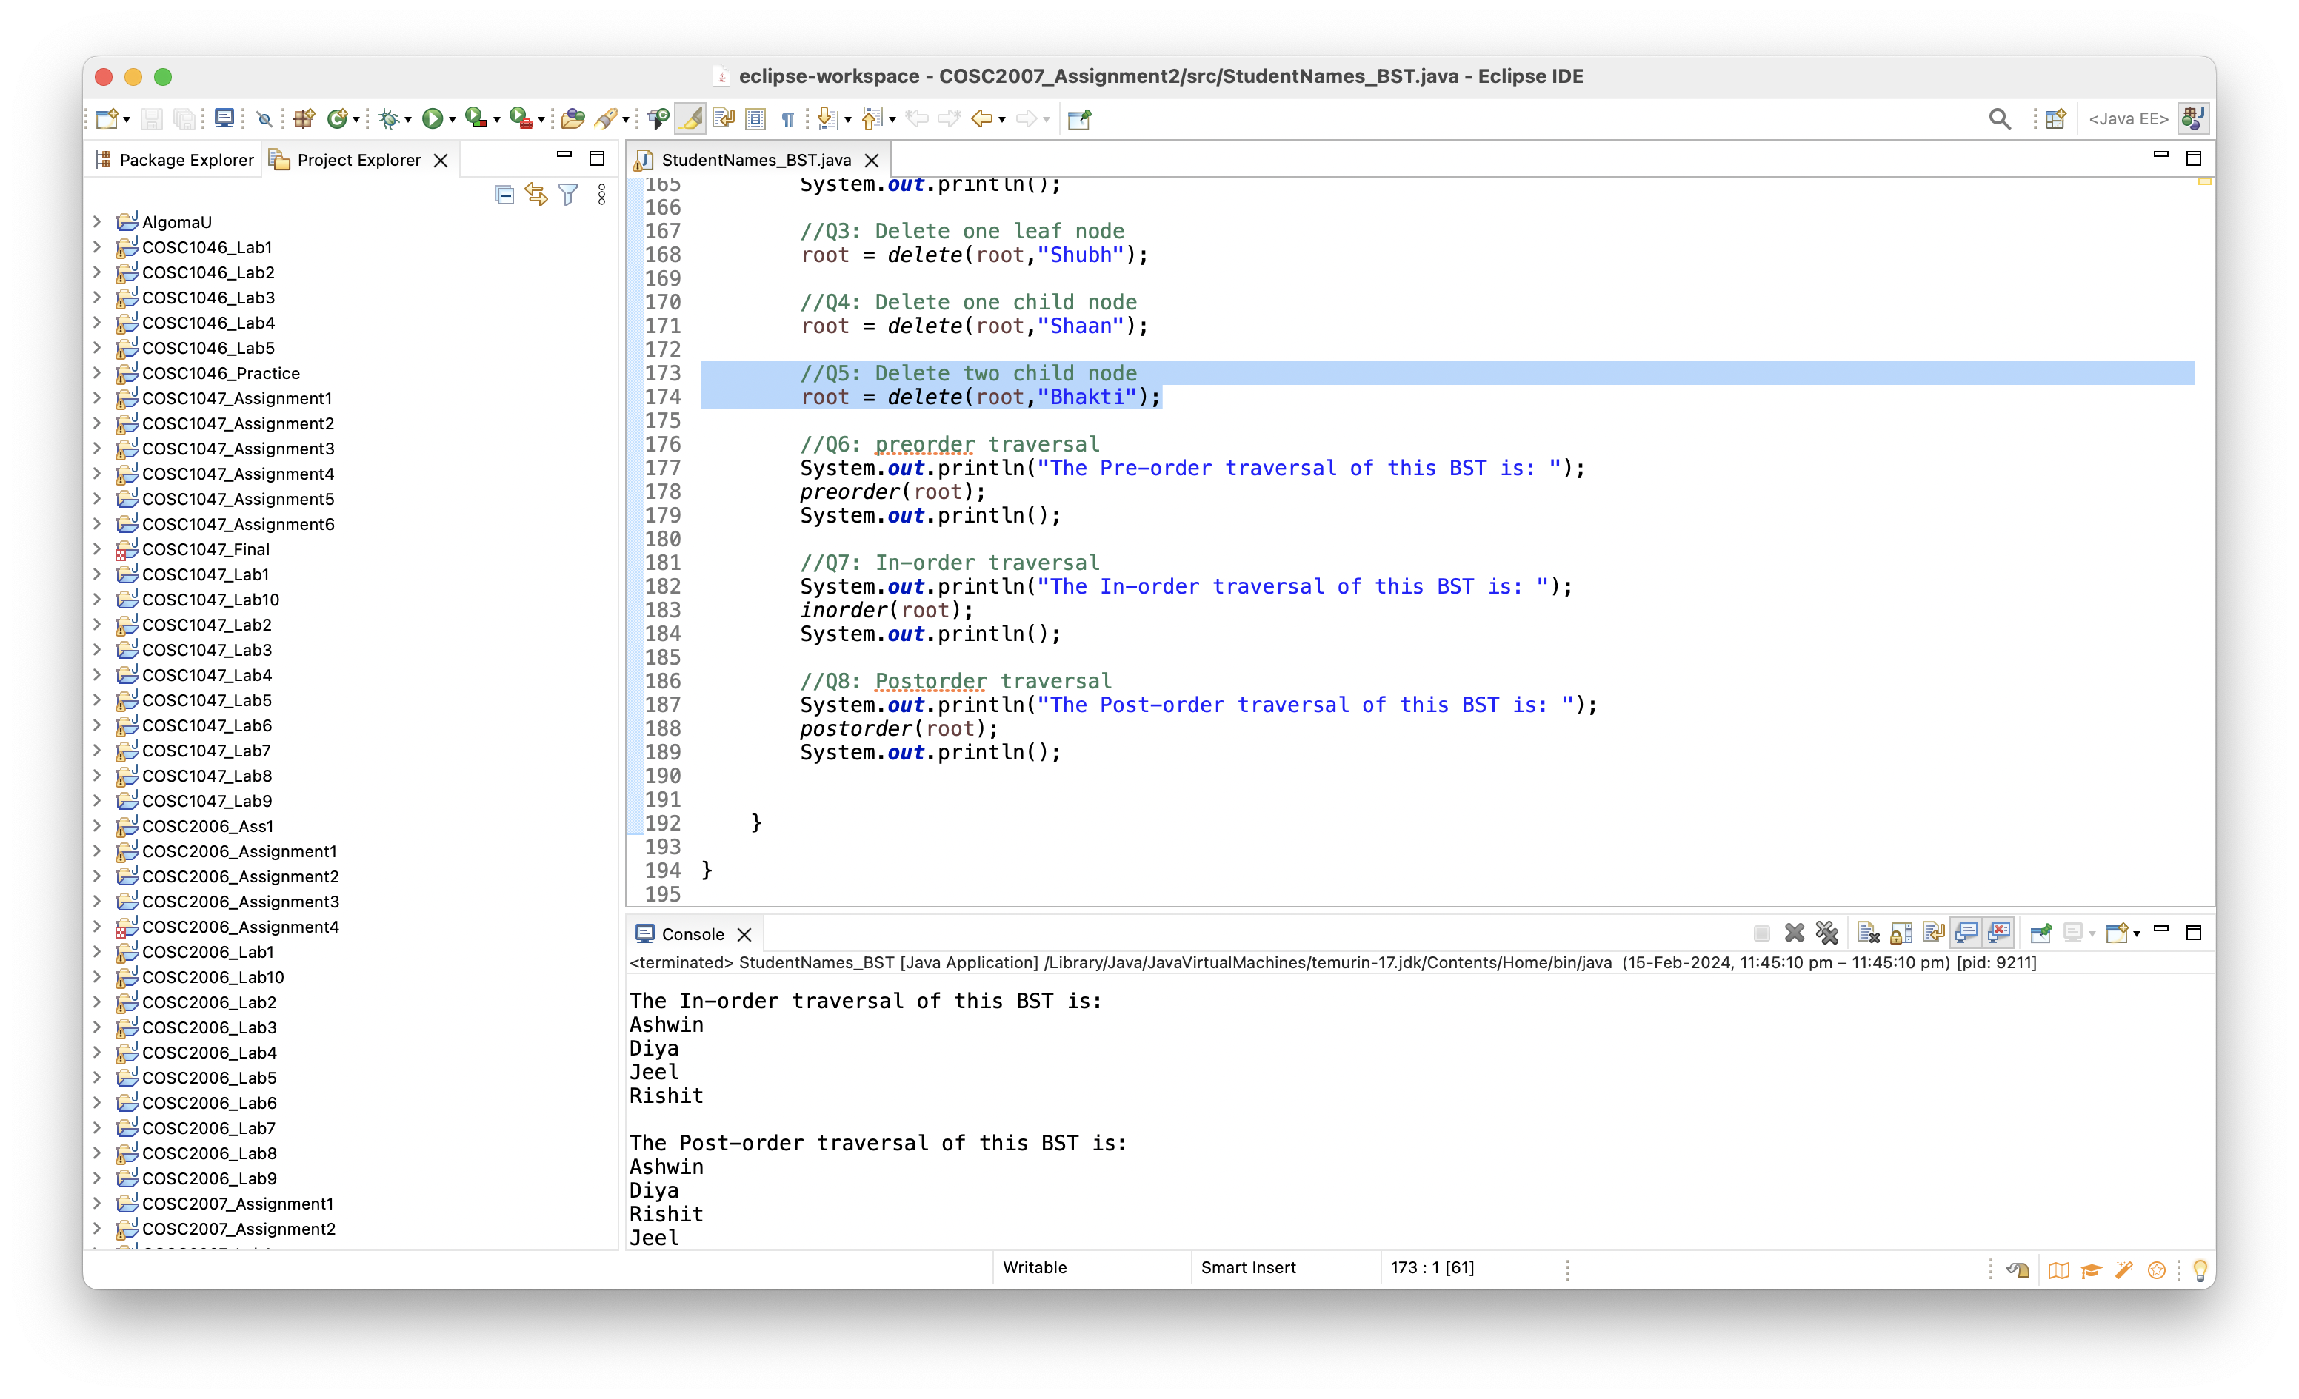

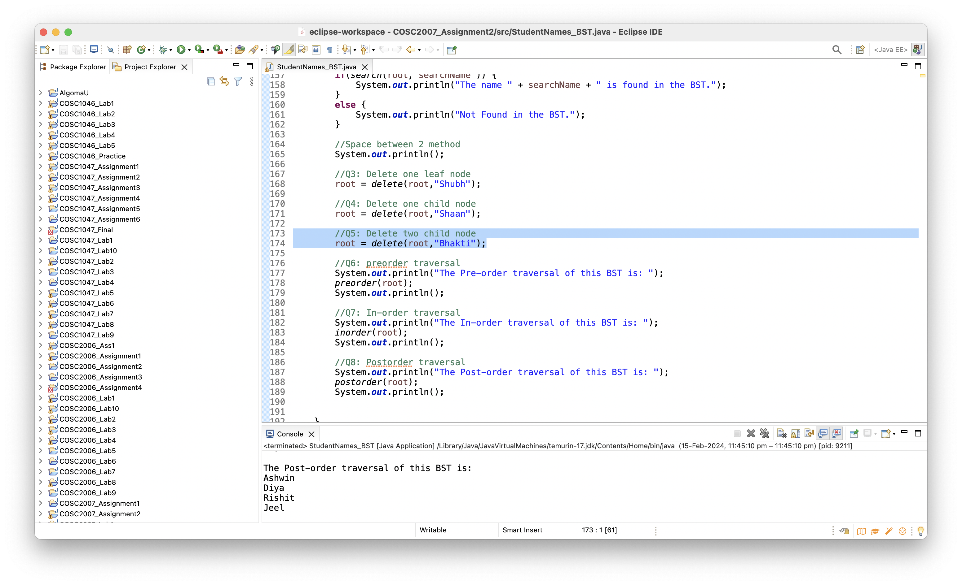

1. - Perform the pre-order traversal

**Algorithm/ Pseudocode**

//Preorder traversal

//check root first, then check left and then right node

**Code**

Preorder Method:

//Preorder traversal = root, left, right

**public** **static** **void** preorder(Node root) {

**if**(root == **null**) {

**return**;

}

System.***out***.println(root.data+ " ");

*preorder*(root.left);

*preorder*(root.right);

}

MAIN METHOD:

//main class

**public** **static** **void** main(String[] args) {

// Q1: Construct a binary search tree

String studentNames[] = {"Jeel", "Rishit", "Bhakti", "Shubh", "Ashwin", "Shaan", "Diya"};

Node root = **null**;

//Multiple insert through for loop

**for**(**int** i=0; i<studentNames.length; i++) {

root = *insert*(root, studentNames[i]);

}

//Q2: Perform the search operation

String searchName = "Harshil";

**if**(*search*(root, searchName )) {

System.***out***.println("The name " + searchName + " is found in the BST.");

}

**else** {

System.***out***.println("Not Found in the BST.");

}

//Space between 2 method

System.***out***.println();

//Q3: Delete one leaf node

root = *delete*(root,"Shubh");

//Q4: Delete one child node

root = *delete*(root,"Shaan");

//Q5: Delete two child node

root = *delete*(root,"Bhakti");

//Q6: preorder traversal

System.***out***.println("The Pre-order traversal of this BST is: ");

*preorder*(root);

System.***out***.println();

//Q7: In-order traversal

System.***out***.println("The In-order traversal of this BST is: ");

*inorder*(root);

System.***out***.println();

//Q8: Postorder traversal

System.***out***.println("The Post-order traversal of this BST is: ");

*postorder*(root);

System.***out***.println();

}

}

OUTPUT:

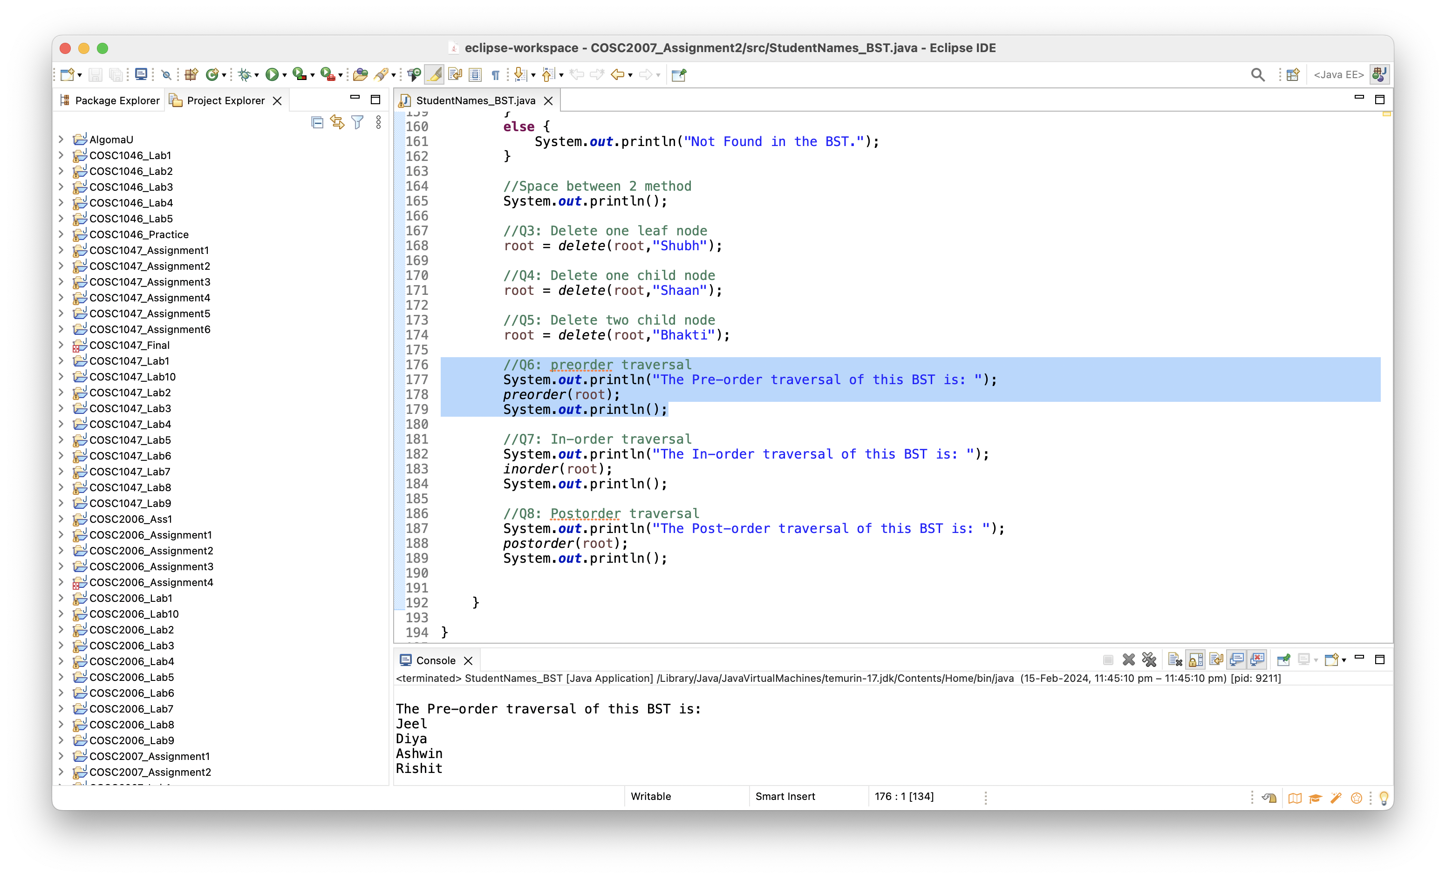

1. - Perform the in-order traversal

**Algorithm/ Pseudocode**

//check left node first

//then root

//then right node

**Code**:

In-order traversal method:

//inorder traversal = Left, root, right

**public** **static** **void** inorder(Node root){

**if**(root == **null**) {

**return**;

}

*inorder*(root.left);

System.***out***.println(root.data+ " ");

*inorder*(root.right);

}

MAIN METHOD:

//main class

**public** **static** **void** main(String[] args) {

// Q1: Construct a binary search tree

String studentNames[] = {"Jeel", "Rishit", "Bhakti", "Shubh", "Ashwin", "Shaan", "Diya"};

Node root = **null**;

//Multiple insert through for loop

**for**(**int** i=0; i<studentNames.length; i++) {

root = *insert*(root, studentNames[i]);

}

//Q2: Perform the search operation

String searchName = "Harshil";

**if**(*search*(root, searchName )) {

System.***out***.println("The name " + searchName + " is found in the BST.");

}

**else** {

System.***out***.println("Not Found in the BST.");

}

//Space between 2 method

System.***out***.println();

//Q3: Delete one leaf node

root = *delete*(root,"Shubh");

//Q4: Delete one child node

root = *delete*(root,"Shaan");

//Q5: Delete two child node

root = *delete*(root,"Bhakti");

//Q6: preorder traversal

System.***out***.println("The Pre-order traversal of this BST is: ");

*preorder*(root);

System.***out***.println();

//Q7: In-order traversal

System.***out***.println("The In-order traversal of this BST is: ");

*inorder*(root);

System.***out***.println();

//Q8: Postorder traversal

System.***out***.println("The Post-order traversal of this BST is: ");

*postorder*(root);

System.***out***.println();

}

}

1. - Perform the post-order traversal

**Algorithm/ Pseudocode**

//check left node first

//check right node

//then at last, node

**Code**

Postorder method

//postorder traversal = Left, Right, root

**public** **static** **void** postorder(Node root) {

**if**(root == **null**) {

**return**;

}

*postorder*(root.left);

*postorder*(root.right);

System.***out***.println(root.data+ " ");

}

MAIN METHOD:

//main class

**public** **static** **void** main(String[] args) {

// Q1: Construct a binary search tree

String studentNames[] = {"Jeel", "Rishit", "Bhakti", "Shubh", "Ashwin", "Shaan", "Diya"};

Node root = **null**;

//Multiple insert through for loop

**for**(**int** i=0; i<studentNames.length; i++) {

root = *insert*(root, studentNames[i]);

}

//Q2: Perform the search operation

String searchName = "Harshil";

**if**(*search*(root, searchName )) {

System.***out***.println("The name " + searchName + " is found in the BST.");

}

**else** {

System.***out***.println("Not Found in the BST.");

}

//Space between 2 method

System.***out***.println();

//Q3: Delete one leaf node

root = *delete*(root,"Shubh");

//Q4: Delete one child node

root = *delete*(root,"Shaan");

//Q5: Delete two child node

root = *delete*(root,"Bhakti");

//Q6: preorder traversal

System.***out***.println("The Pre-order traversal of this BST is: ");

*preorder*(root);

System.***out***.println();

//Q7: In-order traversal

System.***out***.println("The In-order traversal of this BST is: ");

*inorder*(root);

System.***out***.println();

//Q8: Postorder traversal

System.***out***.println("The Post-order traversal of this BST is: ");

*postorder*(root);

System.***out***.println();

}

}

OUTPUT:

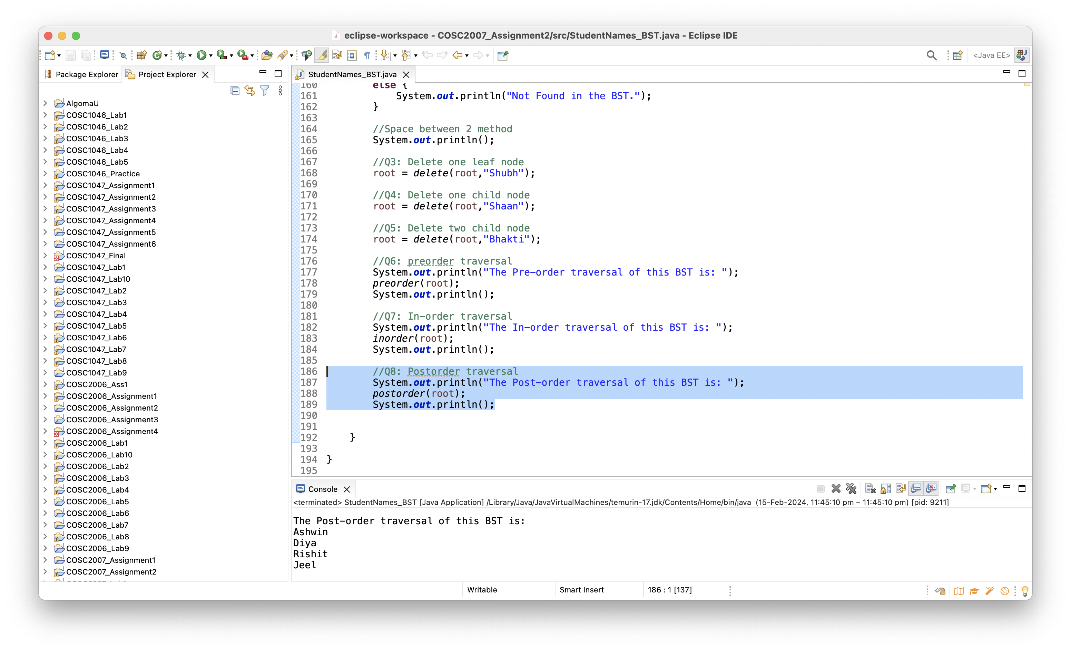

**CONCLUSION:**

The above code is a Java program that implements a binary search tree (BST) of student names. The code defines a Node class that represents a node in the BST, and provides methods for inserting, searching, deleting, and traversing the tree. The main method creates a BST from an array of student names, and performs some operations on it, such as searching for a name, deleting some nodes, and printing the preorder, inorder, postorder traversal of the tree. The code demonstrates the basic concepts and operations of a BST data structure.